Scott Tuschl

3. For the configurations of Fig. 16.61:

- Find the admittance in rectangular and polar form.

- Sketch the admittance diagram.

Fig. 16.61
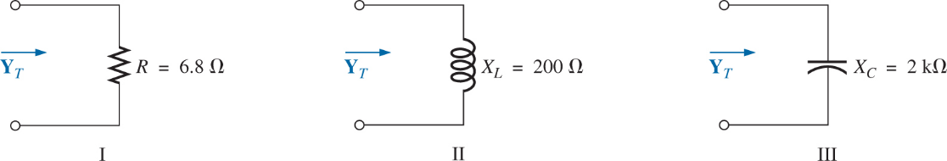

5. For each configuration of Fig. 16.63:

- Find the total impedance in polar form.

- Calculate the total admittance using the results of part (a).

- Identify the total conductance and susceptance parts of the total admittance.

- Sketch the admittance diagram.

Fig. 16.63.
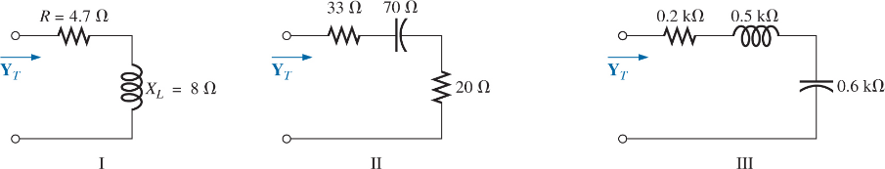

9. For the network in Fig. 16.67:

- Find the total admittance $Y_{T}$ in polar form.

- Draw the admittance diagram.

- Find the voltage E and the currents $I_{R}$ and $I_{L}$ in phasor form.

- Draw the phasor diagram of the currents $I_{S}$, $I_{R}$ and $I_{L}$ and the voltage E.

- Verify Kirchhoff’s current law at one node.

- Find the average power delivered to the circuit.

- Find the power factor of the circuit, and indicate whether it is leading or lagging.

- Find the sinusoidal expressions for the currents and voltage if the frequency is 60 Hz.

- Plot the waveforms for the currents and voltage on the same set of axes.

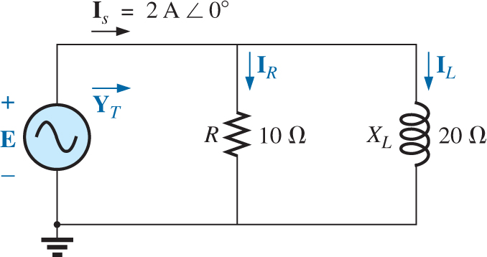

14. Calculate the currents $I_{1}$ and $I_{2}$ in Fig. 16.72 in phasor form using the current divider rule.

Fig. 16.72.
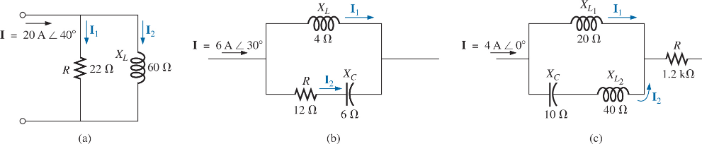

19. For the parallel R-L-C network in Fig. 16.75.

- Plot $Y_{T}$ and $θ_{T}$ (of $Y_{T}$ = $Y_{T}$ ∠ $θ_{T}$) for a frequency range of zero to 20 kHz.

- Repeat part (a) for $Z_{T}$ and $θ_{T}$ (of $Z_{T}$ = $Z_{T}$ ∠ $θ_{T}$).

- Plot $V_{C}$ versus frequency for the frequency range of part (a).

- Plot $I_{L}$ versus frequency for the frequency range of part (a).

Fig. 16.75.
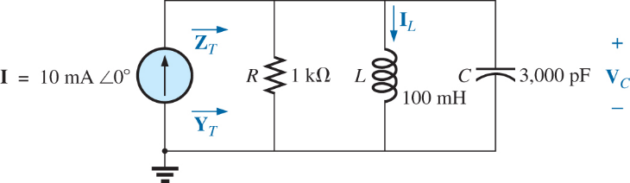

21. For the parallel circuits in Fig. 16.77, find a series circuit that will have the same total impedance.

Fig. 16.77.
